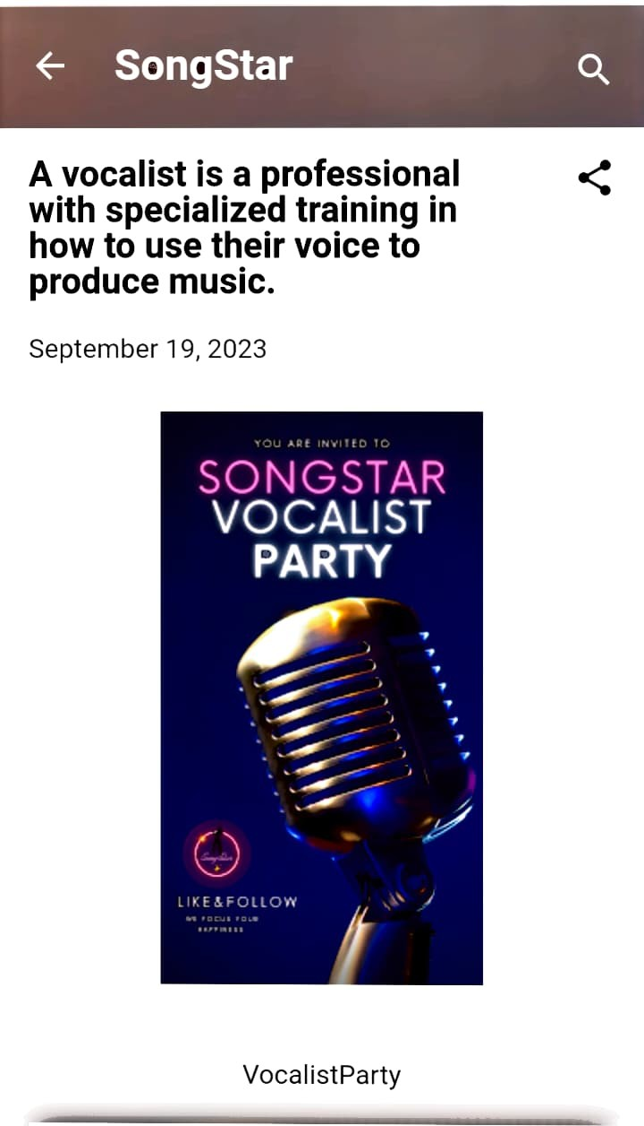

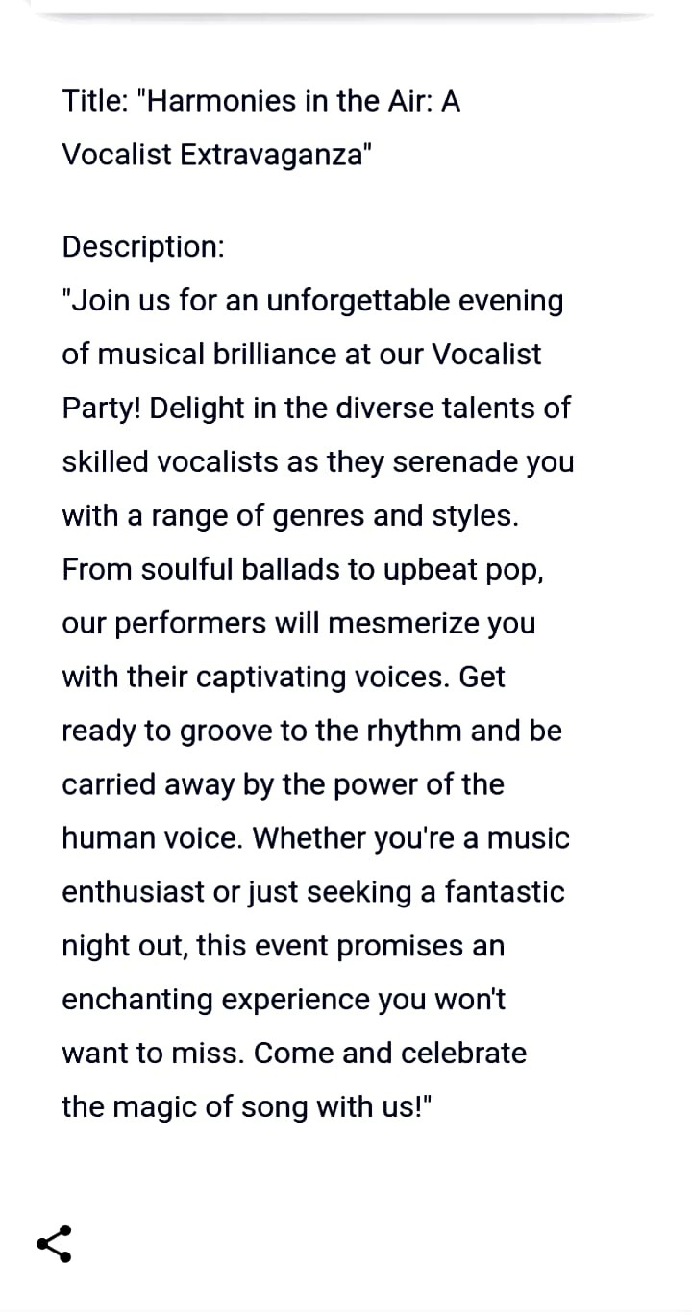link:<https://songstarvocalistparty.blogspot.com/2023/09/a-vocalist-is-professional-with.html>